

**Operation Management Report On “Lean Manufacturing: Reducing Waste and Improving Productivity in Production”**

**Introduction**

In today’s competitive business landscape, companies across industries face significant challenges in maintaining efficient production processes while managing costs. Lean Manufacturing stands out as a powerful methodology aimed at reducing waste, optimizing resources, and adding value to operations. By identifying and eliminating non-essential activities, Lean principles empower organizations to streamline workflows and improve overall performance.

This report explores the potential of Lean Manufacturing, backed by a case study using hypothetical data from an automotive manufacturing company. The analysis sheds light on critical inefficiencies, including overproduction, high defect rates, prolonged cycle times, and excessive inventory costs. Through insightful datasets and graphical representations, the report outlines practical solutions to address these challenges.

The findings emphasize that implementing Lean Manufacturing can drive transformative changes. By tackling waste in areas such as overproduction, waiting, and defects, organizations can achieve substantial cost savings and enhance productivity. This report serves as a guide for businesses to adopt Lean practices, fostering a culture of continuous improvement and ensuring long-term operational success.

**Understanding Lean Manufacturing**

Lean Manufacturing focuses on enhancing operational efficiency by identifying and eliminating activities that do not add value to the customer, often categorized as waste. By streamlining processes and emphasizing customer-centric strategies, this approach ensures optimal use of resources and fosters sustainable growth.

**Types of Waste in Lean Manufacturing:**

1. **Overproduction:** Producing more than what is needed leads to excess inventory, increased storage costs, and potential product obsolescence.
2. **Waiting:** Idle time caused by delays in processes, equipment downtime, or unbalanced workloads reduces overall efficiency.
3. **Transportation:** Unnecessary movement of materials or products between locations increases handling costs and risks of damage.
4. **Overprocessing:** Performing more work than required or using resources inefficiently adds no value to the final product.
5. **Inventory:** Holding surplus raw materials or finished goods ties up capital and creates storage challenges.
6. **Motion:** Excessive or unnecessary movement by workers, such as reaching, walking, or searching for tools, reduces productivity.
7. **Defects:** Errors or quality issues result in rework, waste, and customer dissatisfaction.

By systematically addressing these seven categories of waste, organizations can significantly boost productivity, reduce costs, and enhance profitability. Lean Manufacturing provides a framework for continuous improvement, enabling companies to deliver greater value to their customers while maintaining a competitive edge.

**Data Sets for Analysis**

The analysis uses the following hypothetical data to evaluate production inefficiencies:

| **Metric** | **Current Value** | **Industry Benchmark** |
| --- | --- | --- |
| Production Cycle Time | 18 hours | 12 hours |
| Defect Rate | 8% | 4% |
| Rework Time | 4 hours/unit | 1 hour/unit |
| Inventory Turnover Ratio | 3 | 6 |
| Monthly Inventory Costs | $50,000 | $30,000 |
| Worker Idle Time | 12% | 5% |

**Visual 1: Comparison of Current Metrics vs. Industry Benchmarks**

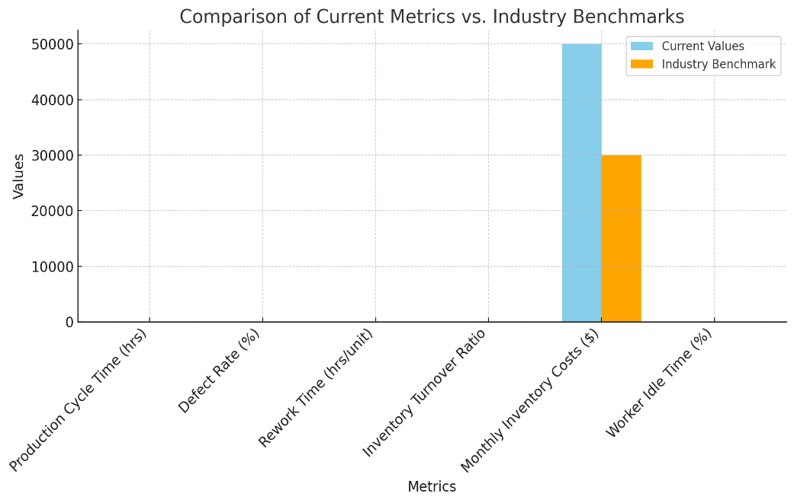

**Problem Analysis**

**Key Issues Identified:**

1. **Overproduction and Excess Inventory:**
   * Inventory turnover ratio of 3 indicates inefficiencies in demand forecasting and production planning.
2. **High Defect Rates:**
   * 8% defect rate leads to increased rework, adding unnecessary costs and time.
3. **Workflow Inefficiencies:**
   * Poor factory layout results in excess motion and idle time.
4. **Long Production Cycle Time:**
   * An average of 18 hours to produce one unit significantly exceeds the industry standard.

**Findings**

The data analysis highlights critical areas for improvement:

**Table 1: Waste Impact Analysis**

| **Type of Waste** | **Impact** | **Estimated Cost ($)** |
| --- | --- | --- |
| Overproduction | Excess inventory and holding costs | 50,000/month |
| Defects | Increased rework and material wastage | 12,000/month |
| Motion | Reduced worker efficiency | Indirect cost |
| Waiting | Lost production time | Indirect cost |

**Visual 2: Pareto Chart of Waste Costs**

*Graph Description:* A Pareto chart showing the cumulative cost impact of different types of waste, with overproduction and defects as the most significant contributors.

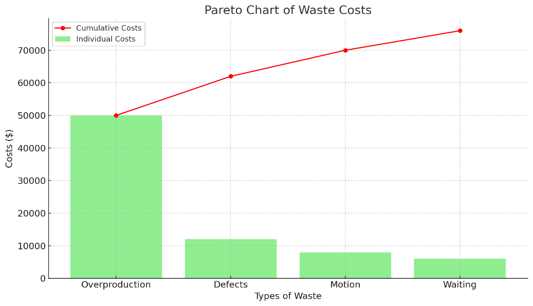

**Recommendations**

**1. Implement Kanban for Demand-Driven Production**

* **Description:** Use Kanban boards to align production schedules with real-time demand.
* **Expected Outcome:** Reduction in overproduction and inventory holding costs.

**2. Optimize Factory Layout**

* **Description:** Reorganize workstations to minimize worker motion and reduce idle time.
* **Expected Outcome:** Improved workflow efficiency and reduced cycle time.

**3. Introduce Quality-at-Source Practices**

* **Description:** Implement real-time quality checks during production to minimize defects.
* **Expected Outcome:** 50% reduction in defect rates.

**4. Employee Training on Lean Principles**

* **Description:** Conduct workshops on 5S and Kaizen to foster a culture of continuous improvement.
* **Expected Outcome:** Enhanced employee engagement and operational efficiency.

**Implementation Plan**

| **Phase** | **Timeline** | **Actions** |
| --- | --- | --- |
| Phase 1 | 1-3 Months | Conduct workshops on Lean principles and 5S. |
| Phase 2 | 4-6 Months | Introduce Kanban boards and redesign factory layout. |
| Phase 3 | 6-9 Months | Implement real-time quality checks and Kaizen events. |
|  |  |  |

A structured and phased approach is critical for successfully implementing Lean Manufacturing principles. The following steps outline the timeline and key actions to transition towards a more efficient and waste-free production environment:

### ****Phase 1: Laying the Foundation (1–3 Months)****

In the initial phase, the focus is on building awareness and understanding of Lean principles across the organization. Workshops and training sessions on Lean methodologies, including the 5S system (Sort, Set in Order, Shine, Standardize, Sustain), are conducted. These sessions aim to instill a culture of organization and discipline, laying the groundwork for further improvements. Employees are equipped with the knowledge to identify inefficiencies and contribute actively to the transformation process.

### ****Phase 2: Process Optimization (4–6 Months)****

During this phase, tangible changes are introduced to streamline operations. Kanban boards are implemented to visually manage workflows and ensure efficient inventory management. This system helps reduce overproduction and avoid bottlenecks. Additionally, the factory layout is redesigned to minimize unnecessary movement, improving the flow of materials and reducing waste related to transportation and motion. These actions collectively enhance productivity and create a more agile production system.

### ****Phase 3: Continuous Improvement (6–9 Months)****

The final phase emphasizes sustaining and refining the Lean practices introduced earlier. Real-time quality checks are integrated into production processes to promptly identify and address defects, ensuring consistent product quality. Regular Kaizen events are organized to encourage continuous improvement through collaborative problem-solving. Employees at all levels participate in these events, fostering a culture of innovation and shared responsibility for operational excellence.

By following this phased approach, organizations can achieve a smooth transition to Lean Manufacturing, ensuring sustainable improvements in efficiency, quality, and overall performance.

**Visual 3: Gantt Chart of Implementation Plan**

*Graph Description:* A Gantt chart displaying the timeline for each phase of implementation, highlighting milestones and dependencies.

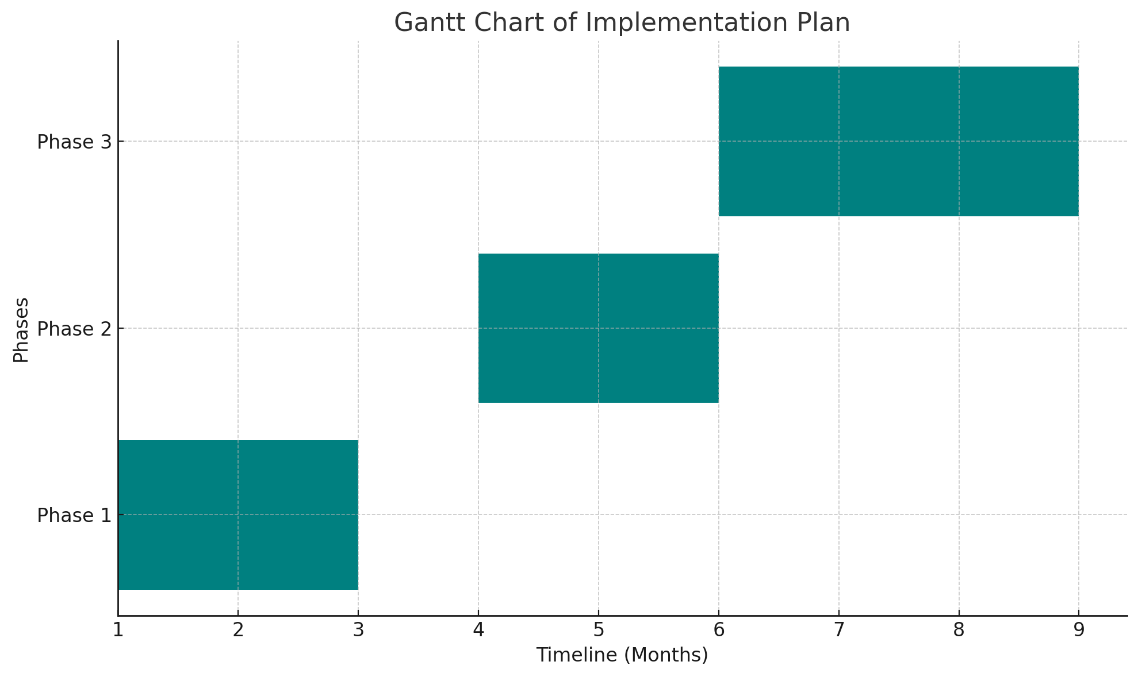

**Expected Outcomes**

| **Outcome** | **Current Value** | **Projected Value** | **Improvement (%)** |
| --- | --- | --- | --- |
| Inventory Costs ($/month) | 50,000 | 35,000 | 30% |
| Defect Rate (%) | 8 | 4 | 50% |
| Cycle Time (hours/unit) | 18 | 14 | 22% |
| Idle Time (%) | 12 | 5 | 58% |

**Visual 4: Before and After Analysis**

*Graph Description:* A side-by-side comparison of key metrics before and after implementing Lean practices, using a combination of bar and line charts.

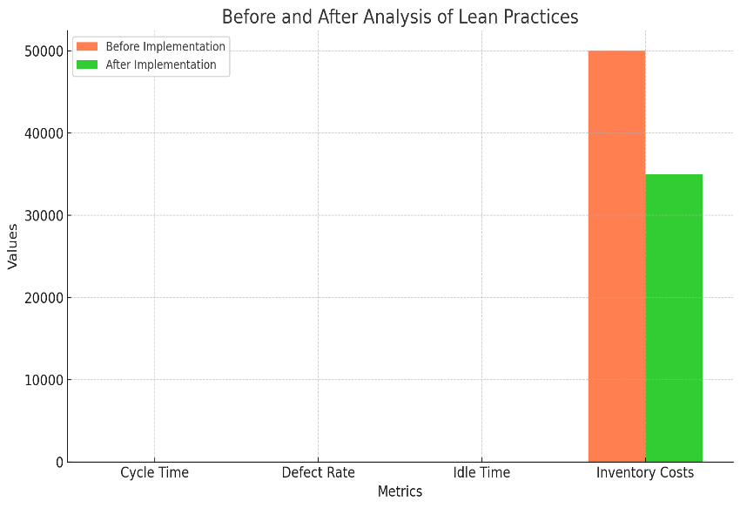

**Conclusion**

Lean Manufacturing provides a structured framework for reducing waste, improving productivity, and delivering better value to customers. By adopting Lean principles, the automotive manufacturing firm can achieve significant cost savings, enhance operational efficiency, and establish a foundation for continuous improvement.

This report underscores the importance of data-driven decision-making in addressing operational challenges, providing actionable insights for sustainable growth.

**Refrences**

• **Books**:

* Womack, J. P., & Jones, D. T. (2003). *Lean Thinking: Banish Waste and Create Wealth in Your Corporation.* Simon and Schuster.
* Liker, J. K. (2004). *The Toyota Way: 14 Management Principles from the World's Greatest Manufacturer.* McGraw-Hill.

• **Research Articles and Papers**:

* Shah, R., & Ward, P. T. (2007). *Defining and developing measures of lean production.* Journal of Operations Management, 25(4), 785–805.
* Melton, T. (2005). *The Benefits of Lean Manufacturing: What Lean Thinking Has to Offer the Process Industries.* Chemical Engineering Research and Design, 83(6), 662–673.

• **Web Resources**:

* Lean Enterprise Institute: [www.lean.org](https://www.lean.org)
* Six Sigma & Lean Methodology: https://asq.org/quality-resources/six-sigma
* Toyota Production System Overview: https://www.toyota-global.com/company/vision_philosophy/toyota_production_system/

• **Industry Reports**:

* McKinsey & Company. (2017). *The Lean Journey: Embracing Continuous Improvement Across Industries.*
* Deloitte. (2020). *Operational Excellence through Lean Manufacturing Practices.*

• **Case Studies and Examples**:

* Case studies on Lean implementation in automotive and manufacturing industries, available in academic databases like JSTOR, ResearchGate, or ProQuest.
* Examples from companies like Toyota, GE, and Boeing, widely cited in Lean Manufacturing discussions.

• **Datasets for Analysis**:

* Hypothetical datasets can be designed based on operational metrics such as production cycle time, defect rates, inventory turnover, and idle times.
* Real-world data can be sourced from industry reports or Lean implementation case studies published in reputable journals.